Simple | Crescent | Hollow | Archipelago
External | External | External | External
Convex Hull | Convex Hull | Convex Hull | Convex Hull
 |  | Hole | Hole
 |  |  | Island

Islands can be treated as separate contours for determining relationships
 | = |  | +

def circle_points(radius, offset_x=0, offset_y=0, num_points=16, precision=3):
deg_step = radians(360/num_points)
degree_points = np.arange(stop=radians(360), step=deg_step)
x_coord = np.array([round(radius*sin(d), precision) for d in degree_points])
y_coord = np.array([round(radius*cos(d), precision) for d in degree_points])

x_coord = x_coord + offset_x
y_coord = y_coord + offset_y
coords = [(x,y) for x,y in zip(x_coord,y_coord)]
return coords


circle_6 = Polygon(circle_points(6))
circle_4 = Polygon(circle_points(4))
circle_2 = Polygon(circle_points(2))
island = shapely.union(shapely.difference(circle_6, circle_4),circle_2)
island



circle_35 = Polygon(circle_points(3.5))
circle_25 = Polygon(circle_points(2.5))
hollow = shapely.difference(circle_35, circle_25)
hollow


shapely.union(island, hollow)

shapely.relate(island, hollow)
'FF2FF1212'

Entire Region | shapely.relate(island, hollow) | FF2FF1212
Exterior | shape = Polygon(island.geoms[0].exterior)  shapely.relate(shape, hollow) | 212FF1FF2
Hole | shape = Polygon(island.geoms[0].interiors[0])  shapely.relate(shape, hollow) | FF1FFF212
Island | shape = Polygon(island.geoms[1])  shapely.relate(shape, hollow) | FF2FF1212

Equals (symmetric)
The interiors of a and b intersect and no part of the interior or boundary of one geometry intersects the exterior of the other.
$\begin{matrix}2 & * & F \\ * & * & F \\ F & F & *\end{matrix}$ '2.F..FFF.'

Overlaps (symmetric)
a overlaps b: both have some but not all points in common.
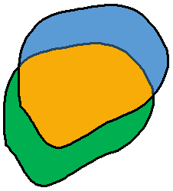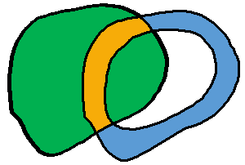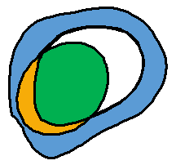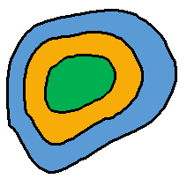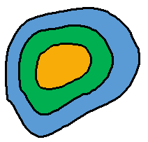
$\begin{matrix}2 & * & 2 \\ * & * & * \\ 2 & * & *\end{matrix}$ '2.2...2..'
$$\frac{2×area\left(a∩b\right)}{\operatorname{area}\left(a\right)+\operatorname{area}\left(b\right)}$$

Borders Exterior (symmetric)
The boundaries of a and b have more than one point in common, but their interiors do not intersect. | $$\begin{matrix}F & F & * \\ F & 1 & * \\ * & * & *\end{matrix}$$  ‘FF.F1....'

Hole vs. Exterior Relation by Border Type
Exterior | Interior | Filled Interior
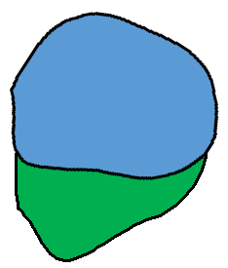
$$\begin{matrix}F & F & 2 \\ F & F & 1 \\ 2 & 1 & 2\end{matrix}$$ | $$\begin{matrix}2 & 1 & 2 \\ F & 1 & 1 \\ F & F & 2\end{matrix}$$ | $$\begin{matrix}2 & 1 & 2 \\ F & 1 & F \\ F & F & 2\end{matrix}$$
‘FF.FF....’ | ‘2...1....’ | ‘2...1....’

$$\frac{2×\overline{\left[\operatorname{perimeter}\left(a\right)∩\operatorname{perimeter}\left(b\right)\right]}}{\overline{\operatorname{perimeter}\left(a\right)}+\overline{\operatorname{perimeter}\left(b\right)}}$$
If the boundary of b is shared with the external boundary of a, then use the perimeter of the external boundary as the perimeter of a. If the boundary of b is shared with a hole in a, then use the perimeter of that hole as the perimeter of a

Delimits/Encompasses
The boundaries of a and b have more than one point in common, and a lies in the interior of b.
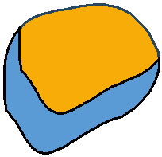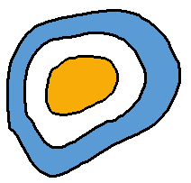
'2.F.1F...'/'2...1.FF.'
$$\frac{\operatorname{area}\left(a∩b\right)}{\operatorname{area}\left(b\right)}$$
What about hole???

Within / Contains
a lies in the interior of b and no points of a lies in the exterior of b.
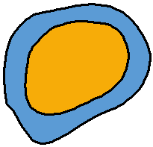
'2.F..F...'/'2.....FF.'
$${Margin}_{⊥}=bounds\left(a\right)-bounds\left(b\right)$$
$${Margin}_{Min}=\operatorname{distance}\left(a,b\right)$$
$${Margin}_{Max}={distance}_{hausdorff}\left(a,b\right)$$

Surrounds/ Embeds
a and b have no interior points in common, and with holes filled b lies in the interior of a.
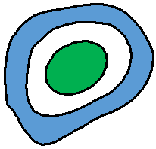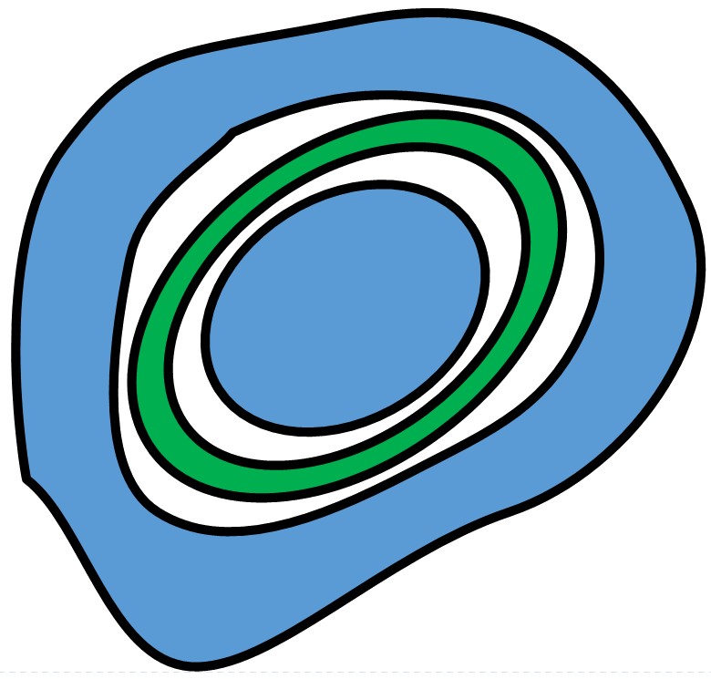
'FF.F.....' + '2.....F..' / 'FF.F.....' + '2.F......'
$${Margin}_{⊥}=bounds\left(a\right)-bounds\left(b\right)$$
$${Margin}_{Min}=\operatorname{distance}\left(a,b\right)$$
$${Margin}_{Max}={distance}_{hausdorff}\left(a,b\right)$$

 | 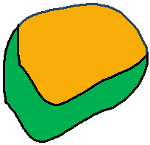 | 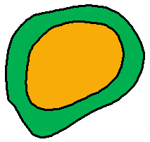 |  | 
 |  |  | 
Overlaps | Delimits/Encompasses | Within / Contains | Surrounds/ Embeds | Borders
a overlaps b: they have some but not all points in common. | The boundaries of a and b have more than one point in common, and a lies in the interior of b. | a lies in the interior of b.  No points of a lies in the exterior of b, and some of the points of the interior of a lie in the interior of b. | a and b have no interior points in common, and with holes filled b lies in the interior of a. | The boundaries of a and b have more than one point in common, but their interiors do not intersect.
'2.2...2..' | '2.F.1F...'  '2...1.FF.' | '2.F..F...'  '2.....FF.'  '2.F..F...' | 'FF.F.....' + '2.....F..'  'FF.F.....' + '2.F......' | 'FF.F1....'
$$\frac{2×area\left(a∩b\right)}{\operatorname{area}\left(a\right)+\operatorname{area}\left(b\right)}$$ | $$\frac{\operatorname{area}\left(a∩b\right)}{\operatorname{area}\left(b\right)}$$ | $${Margin}_{⊥}=bounds\left(a\right)-bounds\left(b\right)$$  $${Margin}_{Min}=\operatorname{distance}\left(a,b\right)$$  $${Margin}_{Max}={distance}_{hausdorff}\left(a,b\right)$$ |  | $$\frac{2×\overline{\left[\operatorname{perimeter}\left(a\right)∩\operatorname{perimeter}\left(b\right)\right]}}{\overline{\operatorname{perimeter}\left(a\right)}+\overline{\operatorname{perimeter}\left(b\right)}}$$

Generate Tree of Structure Shape VS Other Structure shape
- Simple
  - Simple All relations
- Hollow (2 holes)
  - Simple
    - Overlapping
      - Disjoint from holes
      - 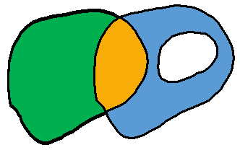
      - Overlapping hole
      - 
    - within
      - Disjoint from holes – within

      - Overlapping hole – overlaps
      - 
      - within hole - surrounds

        - Metrics bases on hole
      - Delimits hole borders
      - 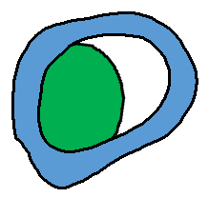
        - Metrics based on hole
      - Contains hole – overlaps
      - 
- Lake ( 2 holes 2 Islands in one of the holes)
- Crescent

 | = |     

